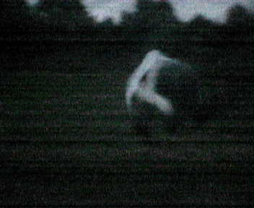
One day when Ben was walking, he saw Ninja Tony jumping around a field. Ben was like, “Hey Tony, have you seen that stupid ass-face around? You know, I think she’s called Laura.”
And Tony was like,
“No Bitch I haven’t. What kind of a stupid name is that anyway?”
And Ben was all like,
“Dunno. It’s pretty DAMN stupid huh?”
Then Ninja Tony jumped home. While Ben was on his travels, he tripped over a cat with a lazer tongue.

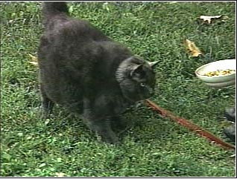

BEHOLD!!!

“BEHOLD!” Said the mysterious Lazerous Cat.
“Give me Fish and I will answer your question”
“Sorry Bud, I’m fresh out of fish” Said Ben and continued on his travels. While Ben was thinking about what to write next, he caught Laura making love to the T.V.
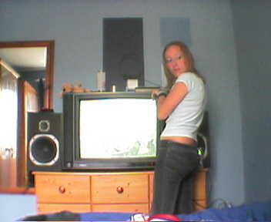

“OI!” Screamed Ben.
“Do you have any fish? I met Cattus Lazerous Toungus a while back and he needs some fish in order to answer me an eternal question.”

Laura then spawned a fish from the back of her
throat.

“Tis an ugly fish. But indeed it is a fish. I will
deliver this immediately.”

Ben Paused…

“By the way. How the fuck did you just cough up a cod?”

“My mother was a carp. When she died, she passed her powers on to me.” She Replied.

“aaaaah” Said Ben and went back to the deadly Cat. He took a crome spade with him, just incase he needed to dig. Ironically, Denzel was there.
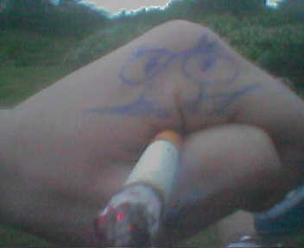

Yes. Denzel.


But Denzel was drunk. ‘n stuff.

Ben decided to sit with Denzel for a while and get drunk. Ben got so damn pissed that he took a picture of himself in the mirror, forgetting that the camera on his phone spins 180 degrees and there was no need.

Ben returned to the cat.

“I return with a fish, O knowledgeable one…”

Ben Bows down.

“I see you got this from your girlfriends great grandmothers, granddaughters daughter. Tis a high quality fish. You’re wish is granted”

Short Silence…

“Ass-faced Laura is at your house humping the TV”
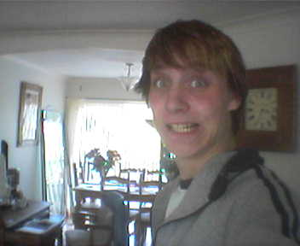

Delighted, Ben says bye and runs home to see Laura.



Ben walks in to find Laura choking on a fish

…And promptly leaves.

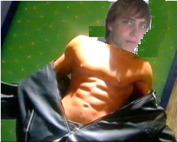
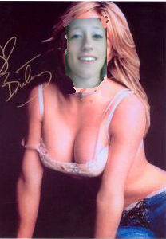
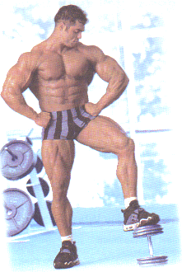
Amazingly, all the writing turns red. And Ben, Denzel and Laura mutate into extremely rich models…

